**Program Homework #2 Polynomial class and data structure**

Due: PM:5:00, April 15, 2020

* **Program design target:**  
  In lecture 2, we introduced three methods to store polynomial data. This program is designed based on the method1 to perform polynomial addition, subtraction and multiplication operations. In this program, it provides required basic operation and program design layout, and you have to make it complete such that the instructions in the main program listed below can be executed correctly.

#include "Polynomial.h"

int main()

{

Polynomial a, b, c, d;

a.set ( 7, 4 ); //7x^4

a.set ( 1, 2 ); //x^2

b.set ( 6, 3 ); //6x^3

b.set ( -3, 2 ); //-3x^2

c = a-b; // (7x^4 + x^2) - (6x^3 - 3x^2) operator overloading of "-"

cout <<a << " - " << b << " = " << c << endl; // print out the c polynomial

c = a + b;

cout << a << " + " << b << " = " << c << endl; // operator overloading of "+"

c = a * b; // (7x^4 + x^2) * (6x^3 - 3x^2), operator overloading of "*"

cout << a << " * " << b << " = " << c << endl; // operator overloading for output polynomial

d = c.differentiate().differentiate(); cout << "differentiate " << c << "two times lead to: "<< endl;

cout << d << endl; // operator overloading <<

cout << c(2) << endl; // evaluate the polynomial with x=2 by horner's method

cin.get();

}

Execution results:

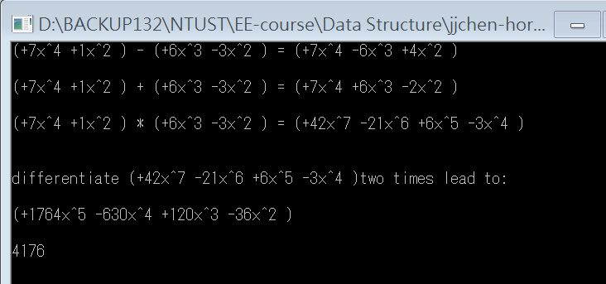

* **What to do: (75%)**

Some functions are partially finished and you are asked to make the program complete. The execution result is shown in the above figure.

1. You have to submit the complete project such that the TA can recompile your programs to test correctness.
2. You have to write a short report to describe
   1. What is all about the program?
   2. What is the time complexity reduction (%) when using Horner’s method instead of brute force one.
   3. What you have done for this program homework?
   4. How will you improve this program?

* **Bonus: (25%)**  
  You can try your best to modify the program such that either the method 2 or method 3 can be utilized to improve the program storage or operation efficiency.
* Note: Please don’t share your program with others. Otherwise, the credits will also be shared by students submit the same program contents.